This form must be completed and submitted by **all teams no later than the date specified in the Action Deadlines on Formula Hybrid website**. The Formula Hybrid Technical Committee will review all submissions which deviate from the Formula Hybrid® rulesand reply with a decision about the requested deviation. All requests will have a confirmation of receipt sent to the team.Impact Attenuator Data (IAD) and supporting calculations must be submitted electronically in Adobe Acrobat Format(*.pdf). The submissions must be named as follows: schoolname_IAD.pdf using the complete school name. **Submit the IAD report as instructed on the event website.**

*In the event that the Formula Hybrid Technical Committee requests additional information or calculations, teams have **one week from the date of the request** to submit the requested information or ask for a deadline extension.

University Name: ____Yale Univeristy_____ Car Number: ________________213__________

Team Contact: ___Taha Ramazanoglu______ E-mail Address: _____taha.ramazanoglu@yale.edu______

Faculty Advisor: _______Joseph Zinter_____ E-mail Address:_____joseph.zinter@yale.edu_________

|  |  |  |
| --- | --- | --- |
| Material(s) Used | Aluminum | |
| Description of form/shape | Honeycomb 5052 5.7pcf 3/16” 4”x8”x10.7” | |
| IA to Anti-Intrusion Plate mounting method | WEST SYSTEM® Six10® Thickened Epoxy Adhesive | |
| Anti-Intrusion Plate to Front Bulkhead mounting method | 4, 5/16 Grade 8 Bolts | |
| Peak deceleration (<= 40 g's) | 18.8 g’s | |
| Average deceleration (<= 20 g's) | 16.3g’s | |
| Vehicle Mass | Amount = 700 lbs | Please Circle: Measured or **Estimate** |

Confirm that the attenuator contains the minimum volume 200mm wide x 100mm high x 200mm long

x

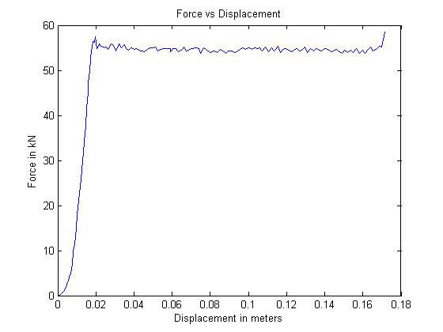

Figure 1: Force-Displacement Curve (dynamic tests must show displacement during collision and after the point v=0 and until force becomes = 0)

**ATTACH PROOF OF EQUIVALENCY**

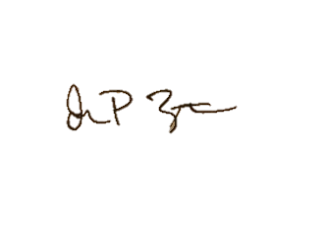TECHNICAL COMMITTEE DECISION/COMMENTS

_______________________________________________________________________________________

Approved by______________Joseph Zinter__________________________________ Date______2/5/16_______

**NOTE: THIS FORM AND THE APPROVED COPY OF THE SUBMISSION MUST BE PRESENTED AT TECHNICAL INSPECTION**

University Name: _______Yale University______ Car Number(s) & Event(s): __#213, Formula Hybrid 2016

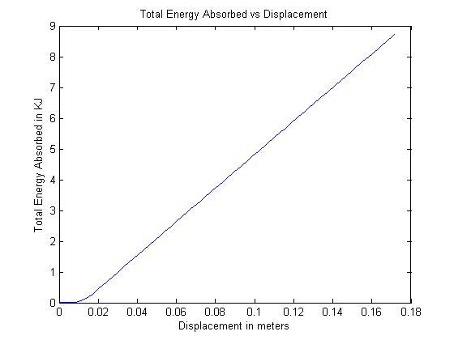

Figure 2: Energy-Displacement Curve (dynamic tests must show displacement during collision and after v=0)

|  |  |  |
| --- | --- | --- |
|  |  |  |

Figure 3: Attenuator as Constructed Figure 4: Attenuator after Impact

*See appended photos for Anti-intrusion plate deformation measurement

|  |  |  |  |
| --- | --- | --- | --- |
| Energy Absorbed (J): | 8,720 | Vehicle includes front wing in front of front bulkhead? | Yes/**No** |
| IA Max. Crushed Displacement (mm): | 171.5 | Wing structure included in test? | N/A |
| IA Post Crush Displacement - demonstrating any return (mm): | -18.0 | Test Type: (e.g. barrier test, drop test, quasi-static crush) | Quasi-static crush |
| Anti-Intrusion Plate Deformation (mm) | 9 | Test Site: (must be from approved test site list on website for dynamic tests) | Yale University, Schroers’s Lab  Instron 5569 |

University Name: _______Yale University______ Car Number(s) & Event(s): __#213, Formula Hybrid 2016

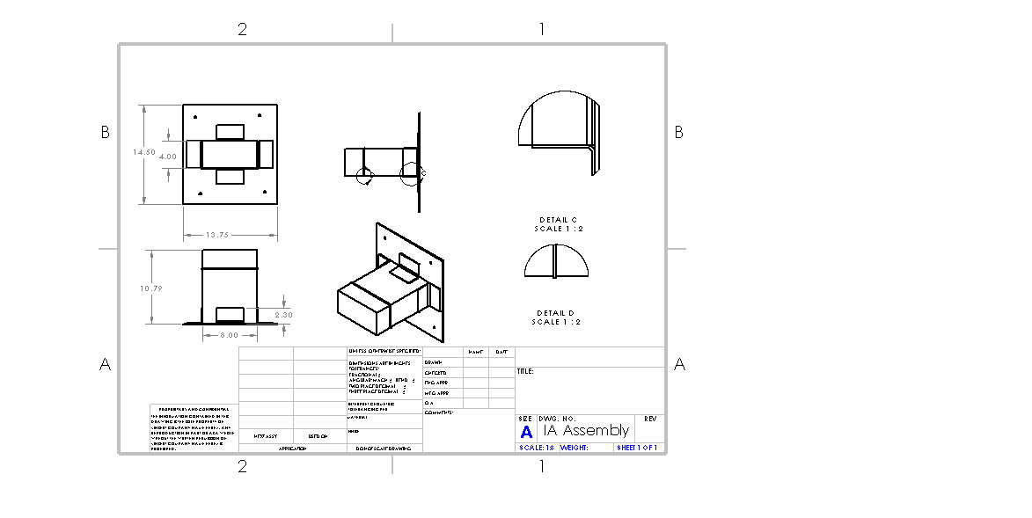

See attached drawings for improved size and quality.

Length (fore/aft direction): __274.1_ mm (>=200mm)

Width (lateral direction): _203.2__ mm (>=200mm)

Height (vertical direction): __101.6_ mm (>=100mm)

Attenuator is at least 200mm wide by 100mm high for at least 200mm: **Yes**/No

***Attach additional information below this point and/or on additional sheets***

Test schematic, photos of test, design report including reasons for selection and advantages/disadvantages, etc. Additional information shall be kept concise and relevant.

University Name: _______Yale University______ Car Number(s) & Event(s): __#213, Formula Hybrid 2016

Test Data Calculations:

The Rules require that our impact attenuator, “when mounted on the front of their vehicle and run into a solid, non-yielding impact barrier with a velocity of impact of 7.0 meters/second, would give an average deceleration of the vehicle not to exceed 20 g, with a peak deceleration less than or equal to 40 g's.”

**Weight:**

We estimate our vehicle will have a mass of mass of about 683 lbs. According to rule T3.21.3, we round this weight up to 700 lbs, or 317.5 kg.

**Peak deceleration:**

Our compression testing yielded a maximum force of 58.5 kN. Generally, acceleration may be calculated as:

$$1. a=F/m$$

For a Force “F” and Mass “m”

For our mass of 317.5 kg, this yields a maximum acceleration:

$$a_{max}=\frac{F_{max}}{m}=\frac{58,500N}{317.5 kg}=184.3\frac{m}{s^{2}}=18.8 g^{'}s$$

Clearly, amax < 40 g’s.

**Average deceleration:**

We used Matlab to calculate a displacement-averaged-force of 50.7 kN over our testing curve. For each displacement unit, we multiplied the differential displacement by the average force over that distance. Finally, we summed each of these products and divided by total displacement to generate a total average force.

For our mass of 317.5 kg, this yields an average acceleration:

$$a_{average}=\frac{F_{average}}{m}=\frac{50,700 N}{317.5 kg}=159.7.3\frac{m}{s^{2}} {=16.3 g}^{'}s$$

Again, aaverage < 20 g’s.

University Name: _______Yale University______ Car Number(s) & Event(s): __#213, Formula Hybrid 2016

**Total Absorbed Energy:**

The Rules require that our impact attenuator decelerate our vehicle from 7 m/s.

At 317.5 kg, our vehicle has Kinetic Energy given by:

$$2.KE=\frac{1}{2}mv^{2}=\frac{1}{2}\left(317.5 kg\right){\left(7\frac{ m}{s}\right)}^{2}=7,779 Joules.$$

Work done on a system at is given by:

$$3. W=F*D$$

for a force “F”, over a distance “D”.

Thus, for a Force vs. Displacement curve, the work done on the attenuator is equivalent to the area under the curve. By conservation of energy, this total work is equivalent to total absorbed KE. We used Matlab to approximate this area as a sum of trapezoidal areas. For our total test displacement of 0.17 meters, we calculated:

Total Energy absorbed = 8,720 Joules

And 8,720J > 7779J.

Design Calculations:

The pre-crushed honeycomb that we purchased nominally compresses at 375 psi +/- 10% (2,586,000 +/- 258,600 Pa) and has a cross sectional area of 8x4 inches (see attached data sheets). We designed for both pressure extremes.

For our design, we used the additional equations to calculate Force “F”:

$$4. F=P*A$$

for an average Pressure “P” and Cross-sectional Area “A,” and:

$$5. D=\frac{v_{f}^{2}-v_{i}^{2}}{(2*a)}$$

to calculate Displacement “D” during a constant acceleration “a.”

University Name: _______Yale University______ Car Number(s) & Event(s): __#213, Formula Hybrid 2016

Our quasi-static compression test found that after an initial elastic deformation, the honeycomb crushed at an average pressure:

$$P_{crush}=\frac{F_{average}}{A}=\frac{55 kN}{(0.203m*0.102m)}=2,556,000 Pa$$

This falls at the middle of the predicted range of pressures, but for safety our impact attenuator needed to perform at both the top and bottom of that pressure range.

**Case 1: Honeycomb crushes at 2.844 MPa**

In this case, higher pressure leads to greater force on the car by equation 4, and shorter displacement during deceleration by equation 5. Therefore, the limiting parameter for a high pressure crush is the 20 g’s maximum average acceleration mandated by rule T3.21.

For this pressure and our cross-sectional area, equation 4 gives:

$$F_{high}=2,844,000 Pa*0.021 m^{2}=59.7 kN$$

By equation 1, this corresponds to a deceleration of about 19.1 g’s, which is less than 20 g’s.

**Case 2: Honeycomb crushes at 2.327 MPa**

In this case, lower pressure leads to lower force on the car by equation 4, and a larger displacement during deceleration by equation 5. Here, the limiting parameter for a low pressure crush is the total ability to absorb KE.

By equation 3, KE absorption is directly proportional to displacement, which means that we need a sufficiently long attenuator for our cross-sectional area. For this pressure, equation 4 tells us that:

$$F=2,327,000 Pa*0.021 m^{2}=48.9 kN$$

By equation 1, this gives us an deceleration of about 153.9 m/s2 . For this minimum deceleration, equation 5 predicts a maximum displacement of about 0.17 meters. After accounting for the roughly 75% stroke efficiency of the honeycomb (see attached data sheet) and 1 cm pre-crushed region, we concluded that we our impact attenuator must be at least 0.236 meters, or 9.3 inches long. Design considerations discussed below led us to build an impact attenuator that was longer, at about 10.7 inches.

Conclusions:

Our quasi-static compression test showed that our IA design met all regulations in rule T3.21. Additionally, our impact attenuator design meets these regulations over the entire range of crush-pressures supplied by the honeycomb manufacturer.